Finding the Mechanical Advantage of the Braking System

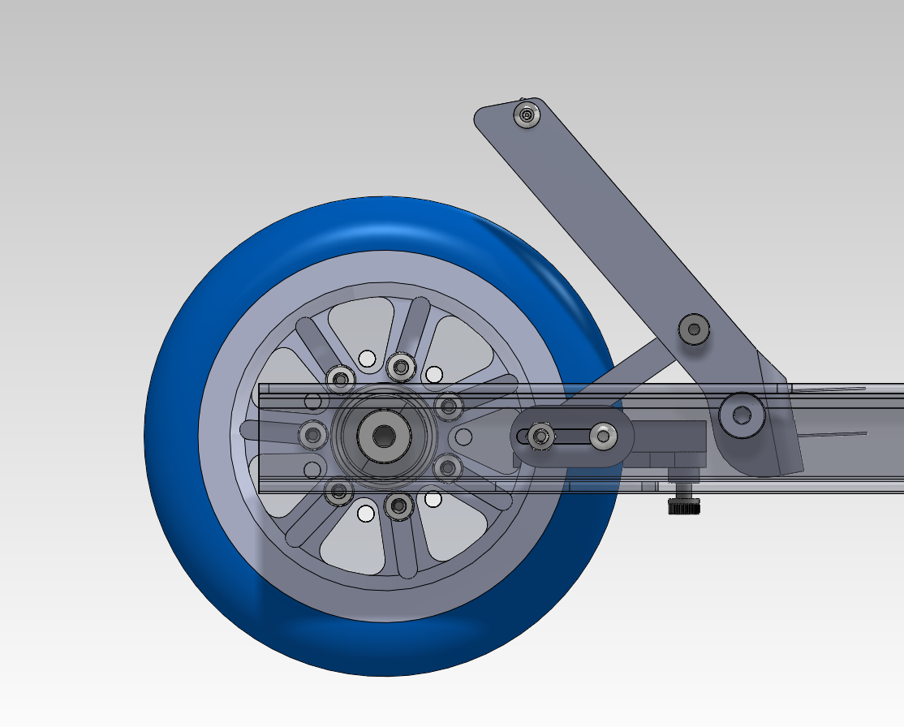
Link C
Link B
Link A
Pedal

Assumptions: Links A, B and C are two force members

Goal: Find the friction force, $f$, applied to the disc based on an applied force, F.

Calculating Friction Force Required for Ideal Stop Time

Assuming a coasting speed of 4 m/s, an ideal gliding stop time is 1.5 seconds, which implies a stop distance of about 10 ft.

$$∆x=\frac{1}{2}\left(v_{c}+v_{s}\right)t$$
$$∆x=\frac{1}{2}\left(4+0\right)\left(1.5\right)=3 m≅10 ft$$

$$a=\frac{v_{s}-v_{c}}{t}=\frac{0-4}{1.5}=2.67\frac{m}{s^{2}}$$

Assuming the average mass of the user is 70 kg and the scooter itself weighs 3 kg, the friction force required for this stop time is 195 N.
$$f=ma$$
$$f=73*2.67=195 N ≅44 lb$$

Calculating Spring Moment
The spring we use on the foot lever applies a moment about point A (see diagram on following page).

$$τ=-kΔθ$$

The change in angle from the pedal’s initial position to its suppressed position is 57.9°-50.2° = 7.7°

$$τ=0.605 in-lb$$

Calculating Mechanical Advantage

F
Pedal FBD Equations

$$\sum{F_{x}}=Rcosθ+F_{Ax}=0$$
$$\sum{F_{y}}=-F+Rsinθ+F_{Ay}=0$$
$$\sum{{M|}_{A}}=-Flcosθ+Rxsinθ+Rycosθ+τ=0$$

$$R\left[xsinθ+ycosθ\right]=F\left[lcosθ\right]-τ$$

$$R=F\frac{\left[lcosθ\right]}{\left[xsinθ+ycosθ\right]}- \frac{τ}{\left[xsinθ+ycosθ\right]}$$

$$τ$$
y
x
pedal
y
x
$$l$$
pt. A
F_{Ax}
F_{Ay}
φ
θ
R
Link A and C Equations

$$R_{x}=Rcosϕ$$

$$R_{x}=\left[F\frac{\left[lcosθ\right]}{\left[xsinθ+ycosθ\right]}- \frac{τ}{\left[xsinθ+ycosθ\right]}\right]cosϕ$$

R_{x}
R_{x}
Link C
Link A
R
R

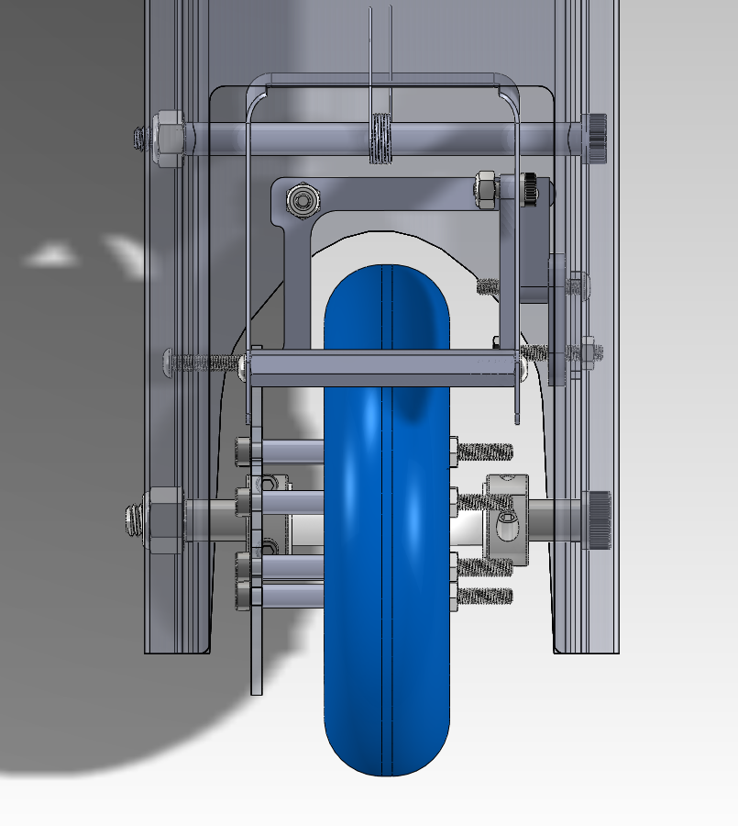
Disc
Caliper
Link B
Link C

Caliper FBD Equations

$$\sum{F_{x}}=-R_{x}+F_{Bx}=0$$
$$\sum{F_{z}}=F_{Bz}+N=0$$
$$\sum{{M|}_{B}}=R_{x}∙w-N∙z=0$$

$$R_{x}∙w=N∙z$$

$$N=\left[F\frac{\left[lcosθ\right]}{\left[xsinθ+ycosθ\right]}- \frac{τ}{\left[xsinθ+ycosθ\right]}\right]\left[\frac{w}{z}\right]cosϕ$$

w
pt. B
x
F_{Bz}
F_{Bx}

z
z
R_{x}

N
Caliper

$$N=\left[F\frac{\left[(2.97)cos⁡(50.2)\right]}{\left[\left(0.38\right)\sin\left(50.2\right)+(0.62)cos⁡(50.2)\right]}- \frac{0.605}{\left[\left(0.38\right)\sin\left(50.2\right)+(0.62)cos⁡(50.2)\right]}\right]\left[\frac{1.72}{1.17}\right]cos⁡(33.6)$$
$$N=\left[2.76*F- .878\right](1.22)$$

Assuming an applied force of 50 lb, when the caliper contacts the disc, the normal force is 168 pounds, giving a mechanical advantage of about 3.3.

Calculating Applied Force Required for Ideal Stop Time

Based on our calculated ideal friction force of 44 lb, and our friction coefficient of (), the normal force needs to be __ which implies an initial force from the user of __.

$$f=μN$$
$$44=μN$$

Therefore, in order to stop in time, our user would need to apply a force of __ pounds.

Table 1: List of Variables
Variable | Description | Value When Caliper Contacts Disc
v_{c} | Coasting speed of scooter
v_{s} | Stopped speed of scooter
m | Mass of user and scooter
a | Acceleration
$$τ$$ | Torque from spring
k | Spring constant | 4.5 in-lb
θ | Angle of pedal from horizontal | 50.2˚
F | Applied force
R | Resultant force on link A from pedal
φ | Angle of R from horizontal | 33.6˚
F_{Ay} | Vertical resultant force at pt. A
F_{Ax} | Horizontal resultant force at pt. A
$$l$$ | Length of pedal from applied force F to pt. A | 2.97 in
x | Horizontal distance from R to A | 0.38 in
y | Vertical distance from R o A | 0.62 in
R_{x} | Resultant force on Link C
w | Horizontal distance from pt. B to Link C | 1.72 in
z | Vertical distance from pt. B to force N | 1.17 in
F_{Bx} | Vertical resultant force at pt. B
F_{Bz} | Horizontal resultant force at pt. B
N | Normal force exerted on caliper from disc
$$f$$ | Friction force on disc
μ | Friction coefficient between disc pad and disc

Table 2: List of Equations
Equation Number | Equation | Description
1 | $$∆x=\frac{1}{2}\left(v_{c}+v_{s}\right)t$$ | Kinematic equation 1
2 | $$a=\frac{v_{s}-v_{c}}{t}$$ | Kinematic equation 2
3 | $$f=ma$$ | Newton’s Second Law
4 | $$τ=-kθ$$ | Hooke’s Law
5 | $\sum{F}=0$, $\sum{M}=0$ | Newton’s Third Law
6 | $$f=μN$$ | Friction Equation

